FUNDAMENTALS OF DEFENSE: Counterattack!
By
GM Bong Villamayor
Powerchess Asia

Defense is one of the most difficult aspects in the game of chess. Defending against enemy threats requires proper evaluation of the position.
If you are being attacked and you think that there is a possibility to fight back at the same time, that moment is called counterattack.
It is not easy to spot counterattack especially in complicated positions one must have the ability to identify tactical possibilities in the position. Looking at the pieces and pawns of both sides is a good way of recognizing threats.
Always remember that active play (counter play or counterattack) is the best form of defense.

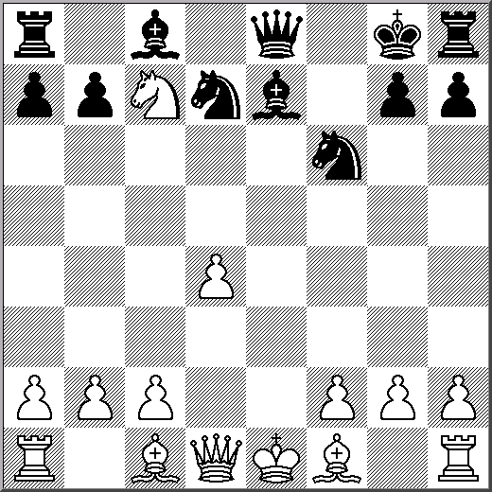
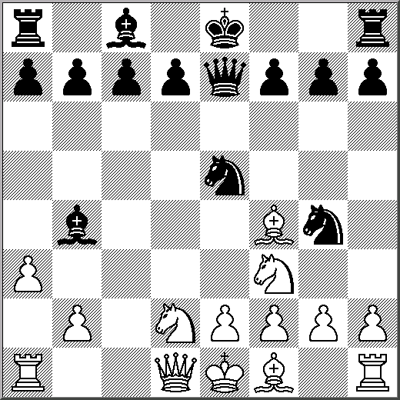
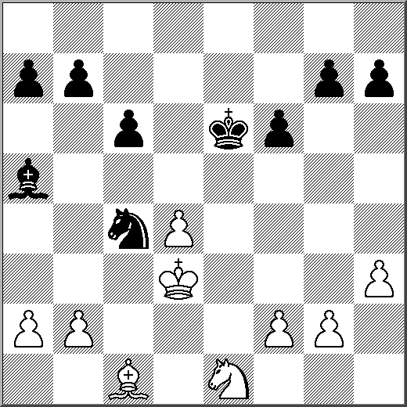
1/B 2/B 3/W

4/B 5/W 6/W
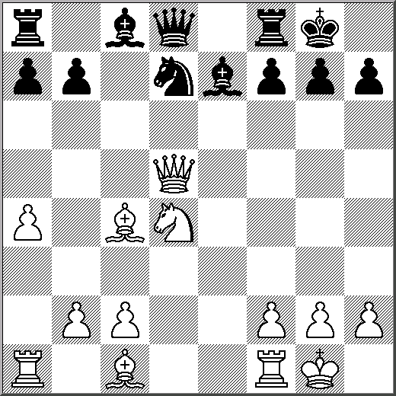
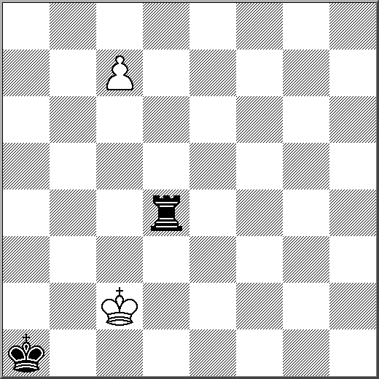
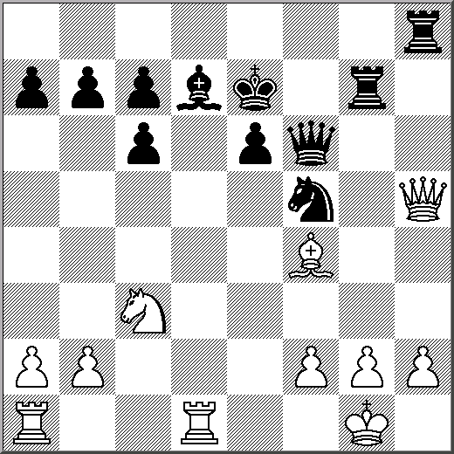

7/B 8/B 9/W
